|  |  |
| --- | --- |
| **Soal Praktikum**  *Practicum Case* |  |
| ISYS6028  Database Systems |
| **Teknik Informatika**  *Computer Science* | O221-ISYS6028-DW01-10 |
| **Periode Berlaku Mulai** Semester Ganjil 2017/2018  ***Valid on*** *Odd Semester Year* 2017/2018 | **Revisi 00**  *Revision 00* |

**Learning Outcomes**

* Design database using structured data model

**Topic**

* Session 10 – Normalization & Entity Relationship (ER) Modelling

**Sub Topics**

* **Normalization Process**
* **UNF, 1NF, 2NF, 3NF**
* How to use ER Modelling in database design
* Basic concepts associated with ER Modelling
* A diagrammatic technique for displaying an ER Modelling

**Normalization**

Normalization is a technique to generate a set of relationships with a variety of desirable properties, providing the data requirements of an enterprise. The purpose of normalization is to produce an accurate representation or preparation of the data, relationships, and boundaries.

The main objective of the normalization is to prevent redundancy and data anomalies. Redundancy is a form of data collection in which the data is already stored repeatedly so the process is complicated and difficult to understand. Besides, it can give the result in a waste of memory and storage capacity.

Here is an example of a table that still has data redundancy and has update anomaly condition:

|  |  |  |  |  |  |  |  |
| --- | --- | --- | --- | --- | --- | --- | --- |
| Clothing ID | Clothing Name | Design Date | Convection ID | Convection Name | Convection Address | Convection Phone | Convection Fee |
| CL020 | aRd DENiM Premium Chino Blue Sky | 2013-06-30 | CV010 | Ornare Convection | Ap #673-9396 Semper. Ave | 021212108141 | 12 |
| CL012 | Kakuu Basic Cardigan Waist String Yellowish Green | 2013-01-17 | CV011 | Ligula Consectetuer Rhoncus Convection | P.O. Box 825, 5447 Est St. | 021628542459 | 11 |
| CL014 | Minimal Flutter Dress Lava Orange | 2013-01-23 | CV011 | Ligula Consectetuer Rhoncus Convection | P.O. Box 825, 5447 Est St. | 021628542459 | 11 |
| CL002 | BLOUSE Y3310 Blue-im | 2012-02-21 | CV012 | Luctus Sit Amet Convection | 989-7677 Fringilla. Rd. | 021809293153 | 15 |
| CL008 | Clothmakers Premium Cotton Polo White | 2012-10-20 | CV013 | Et Commodo Convection | 400 Scelerisque Road | 021959178500 | 16 |

Anomalies are classified into 3, such as:

1. Insertion Anomalies

There are situations where of certain facts cannot be included at all. Insertion Anomalies can be analogous to the two cases below:

* 1. If you do insert into the table above, then you must enter the appropriate details. For example, when we perform inserting clothing (clothing) that will be produced in the convection which has id CV011, then you must enter the details of convection CV011 appropriately and correctly. Different data entry it will cause data inconsistent. This is called the insertion anomalies.
  2. Second case occurs when there is a new convection has not been doing the clothing production, then convection cannot be put into the table, except the table contains NULL.

1. Deletion Anomalies

Deletion Anomalies is a loss of data due to the elimination of unwanted other data. If you do the deletion of data from the above table that represents clothing (apparel) last produced in a convection, then the details of the convection will be deleted as well. On the other hand, you will need all the details of the convection to the data you store. This case is called deletion anomalies.

1. Update Anomalies

If you make changes to a record, for example, change the address data on ConvectionId CV011, then you need to make changes to all data of made garments in the convection. This case is called modification anomalies.

There are some steps to do normalization:

1. **Unormalized Form**(**UNF**)

Is an initial table that has not been normalized containing one or more repeated data sets. To create a UNF table is to move data from resources into a table with rows and columns format, if there are attributes that have a lot of value (multivalue), it will get into UNF.

1. **First Normal Form**(**1NF**)

To change from **UNF** into **1NF**, you must specify the **primary** **key** for **UNF**, eliminating redundant data by placing the redundant data by duplicate the original key attribute into a new table (relation), and divide columns that containing multiple values to become a new table.

1. **Second Normal Form**(**2NF**)

To change from **1NF** into **2NF**, for all non-primary key attributes is functionally dependent on the primary key, remove **partial** **dependency** of column by placing it on a table (relation) to become a new functional dependency.

**Partial dependency** is the relation between non-primary key attribute that depends on part of a composite key.

1. **Third Normal Form**(**3NF**)

To change from **2NF** into **3NF**, there is no non-primary key attributes that depends functionally with the other non-primary key, and remove **transitive** **dependencies** by putting on a new table (relation).

**Transitive** **dependency** is a relation in which a non-primary key attribute that depends on other non-primary key attribute.

Example of **transitive** **dependency** relation can be shown on the table above:

* 1. ConvectionAddress and ConvectionPhone depends on ConvectionID.
  2. ConvectionPhone and ConvectionID depends on ConvectionAddress.
  3. ConvectionAddress and ConvectionID depends on ConvectionPhone.

**Soal**

*Case*

**Laundry Store**

**Laundry Store** is one of the most famous laundries around Bina Nusantara University. Because there are so many transactions that occur every day, **Laundry Store** has trouble sorting out their sales. To assist them in sorting their data, the company decided to hire you to work and make an application to help them.

As a system analyst, you’re assigned to design a database by using normalization UNF, 1NF, 2NF, and 3NF, along with the ERD based on the forms and existing business process.

Here is the business process of **Laundry Store**:

To take the order **Laundry Store**, firstly, list the name of the employee that serves the customer. After listing those, the employee will start listing the item being sent to the laundry. After all items listed, a total amount of the payment will be calculated. The customer and employee will held onto **Laundry Receipt**. Customer can pay via transfer, credit, or cash.

**Laundry Store** also lists the employee absence status, the first thing the employee should do is signing in to take their attendance. The laundry store attendance time is at 07:00 AM, above 07:00 AM the attendance status will be absent. This item will be recorded in the **Employee Absence**. The **Employee Absence** will be printed once every day.

These are the provided forms:

1. **Laundry Receipt**

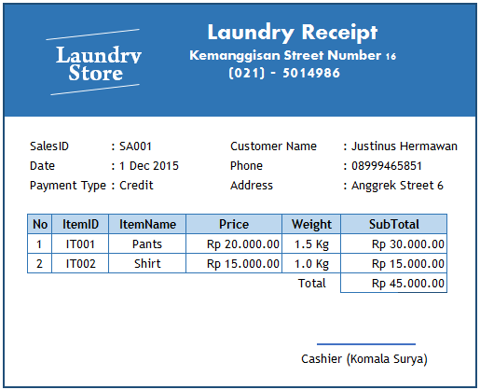

1. **Employee Absence**

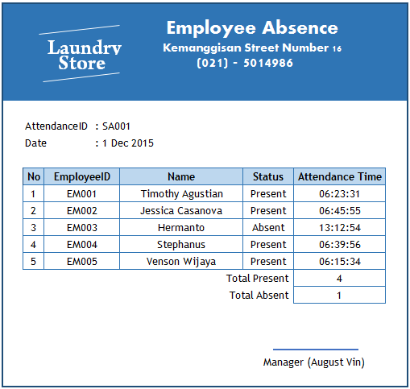

**Reference:**

* Connolly, T., Begg, C., & Holowczak, R. (2008). Business Database Systems. Pearson Education. England.

**If you don’t understand, please ask your assistant!**